**How to transition from Dual Enrollment student to Traditional Student**

Go to fscj.edu and click the APPLY button:

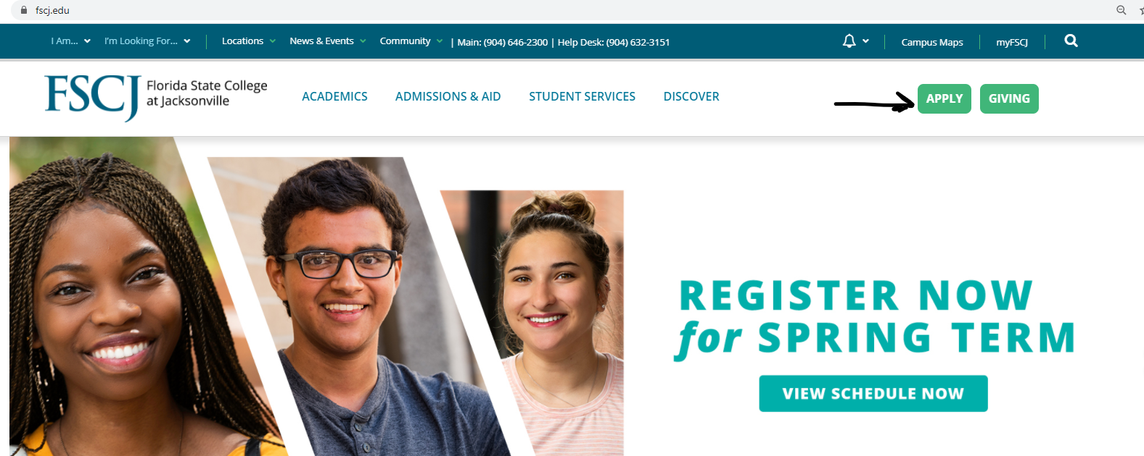

On the next screen, if you originally submitted your application online (late Fall 2020 or Spring 2021 for Spring 2021 new registration only) you will click the Sign In button and use the original e-mail and password you established at that time. There is a Forgot Password option if you need it.

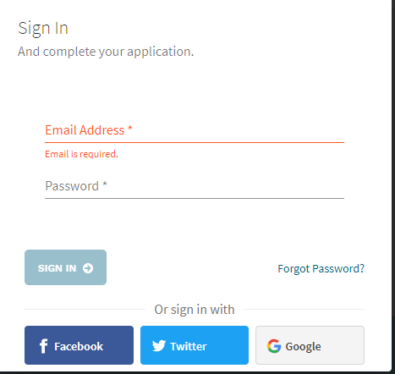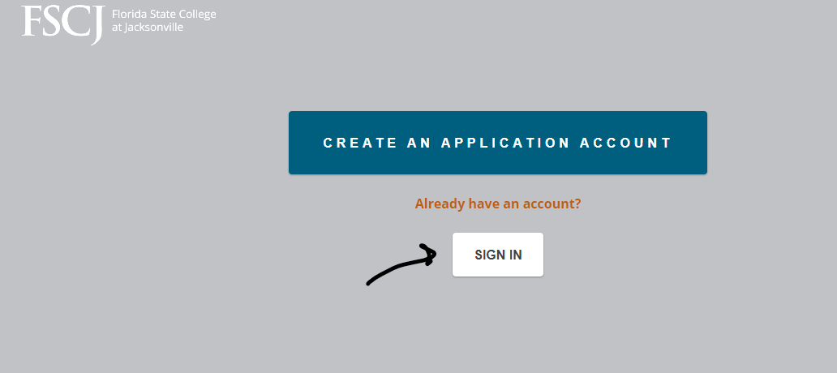

If you have been taking classes in the FSCJ Dual Enrollment program before Spring 2021, you will not have an application in the system and need to create a New Application Account. Click on CREATE AN APPLICATION ACCOUNT.

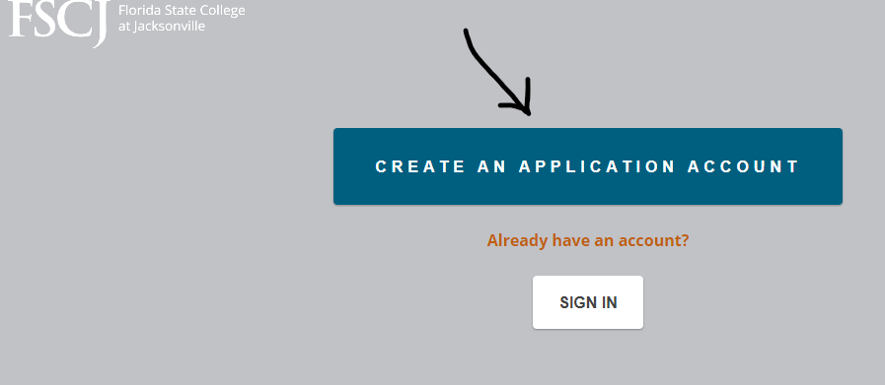

In the Start your application screen, click on General Application (NOT Dual Enrollment Student).

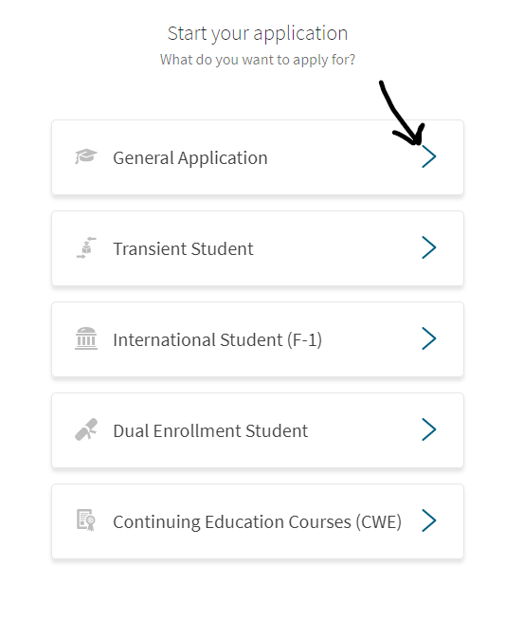

Then fill in your e-mail, a password (write it down), your First Name, Last Name, Date of birth, When do you want to start classes, Your Educational Goal (read through the selections before you make your choice), Program of Study. Then click on Create Account.

***Please note that there is an Application Fee of $25 to submit your application.***

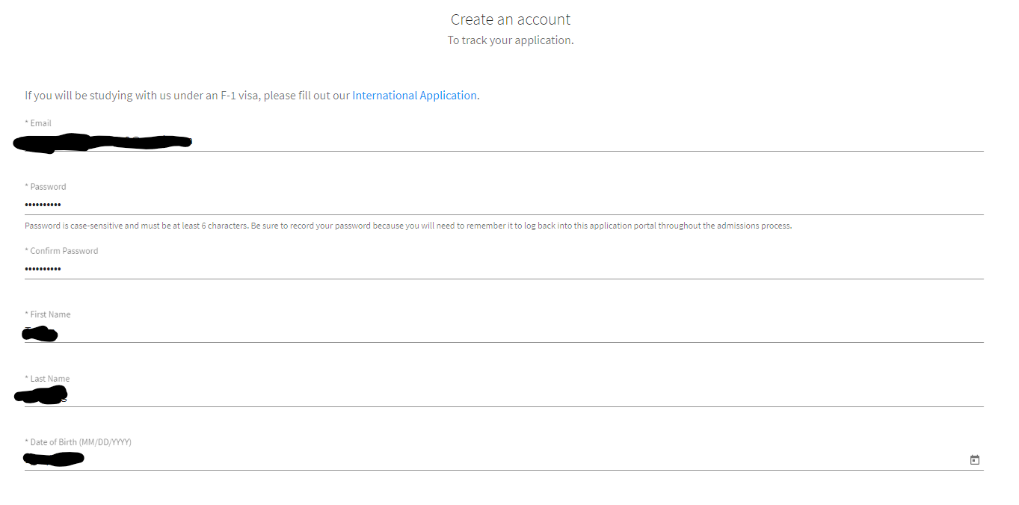

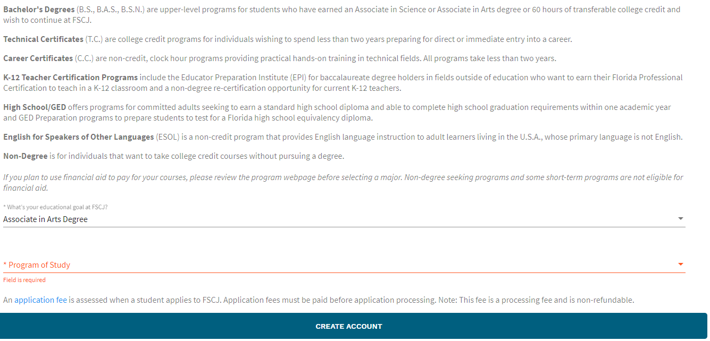

You will then be sent to the Application Dashboard to submit your information.

Click on Start Application. Please note that in the lower right-hand portion of the screen there is a link to chat with FSCJ personnel if you have questions while putting in your application. This chat is available 8 am -6 pm Monday – Thursday, and 9 am – 3 pm on Friday. On the left side of the screen is a Dashboard showing your progress through the application.

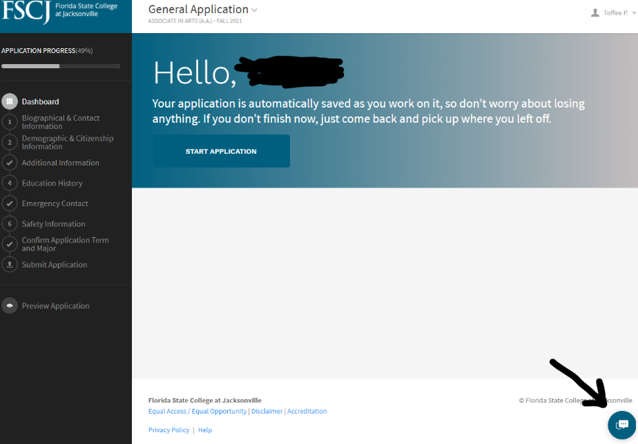

On the next screen, you will add your Biographical and Contact Information to include address and phone number. When you are finished on this page, click on Go to Next Step.

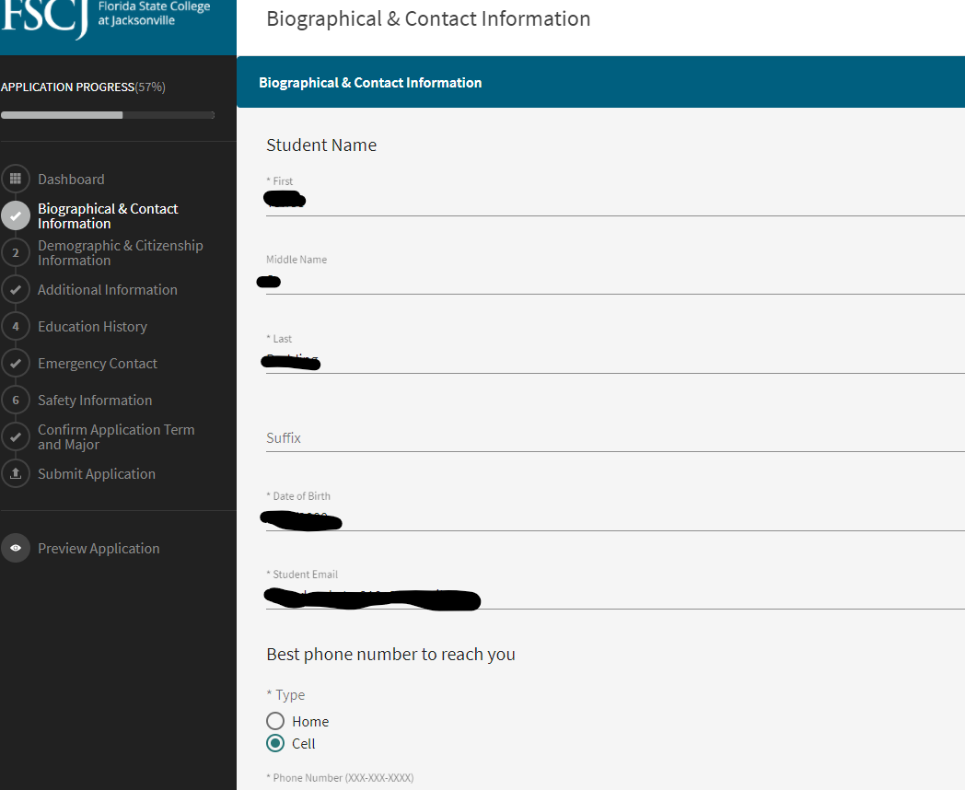

The next page will ask for demographic and citizenship information to include your Social Security number. That number is needed to assist with your financial aid and scholarships.

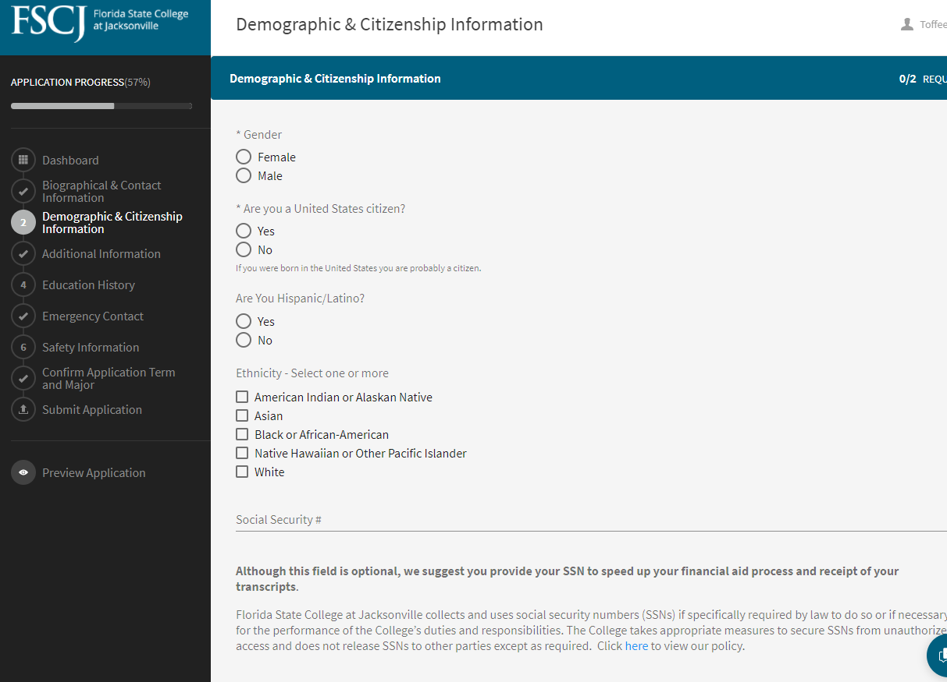

The next page, Additional information will ask if you are interested in Campus Housing, if you have an affiliation with the military, and If you have enrolled at FSCJ before.

Because you are a dual enrollment student, you need to click the Yes button on the last question.

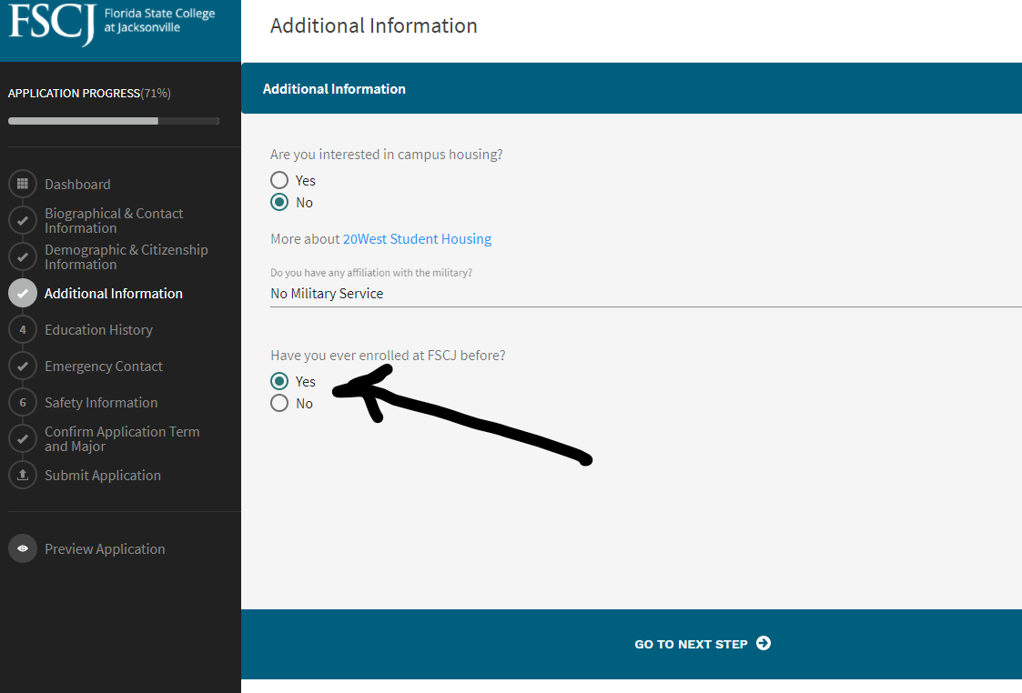

On the next page you will add your schools. First put in your high school-including Home School if applicable. Once you put in that information, including your high school graduation date, you will click SAVE and then Add another school.

Then because you are a dual enrollment student, you need to add College—Florida State College at Jacksonville in Jacksonville, FL.

Unless you are completing your AA degree at the same time you graduate high school, you will click No on the question asking Did you or Will you graduate from this school. Then click SAVE.

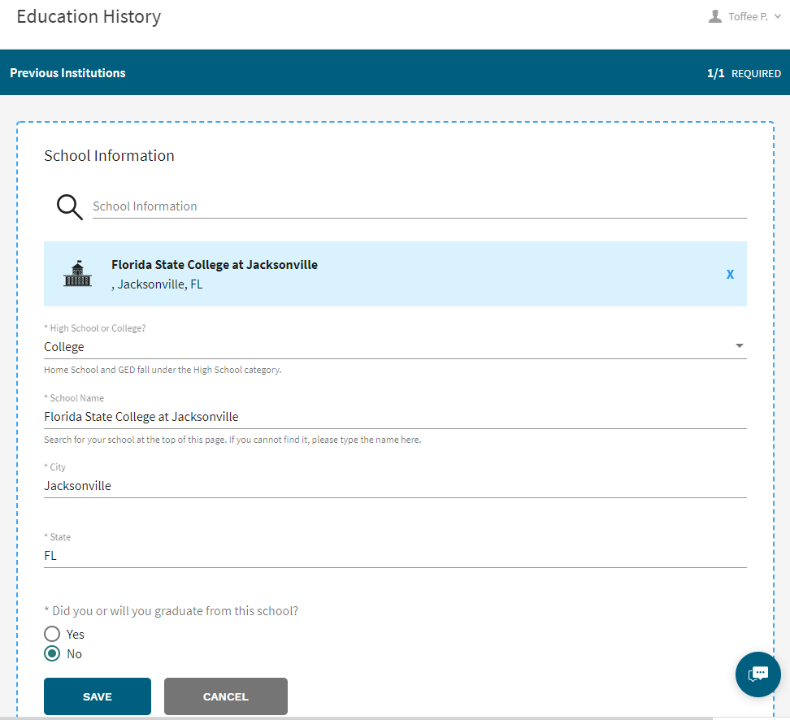

When finished, you will go to the next step and fill in information on your emergency contact.

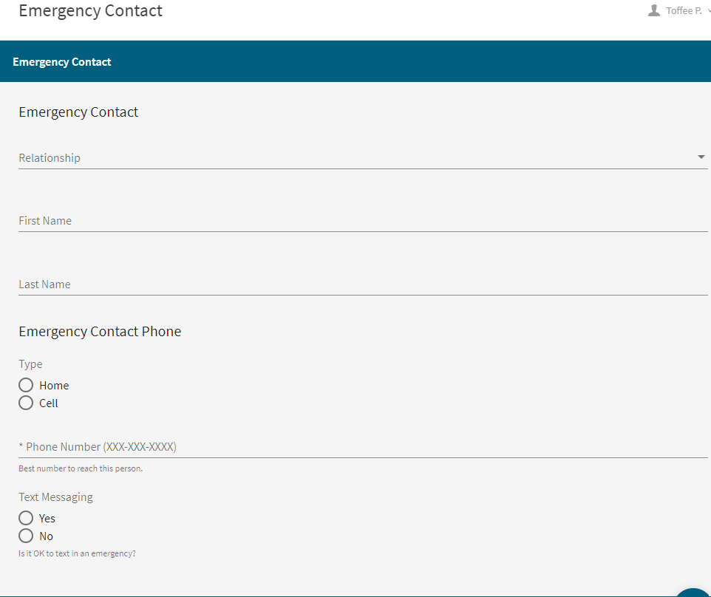

The next page will verify Safety Information:

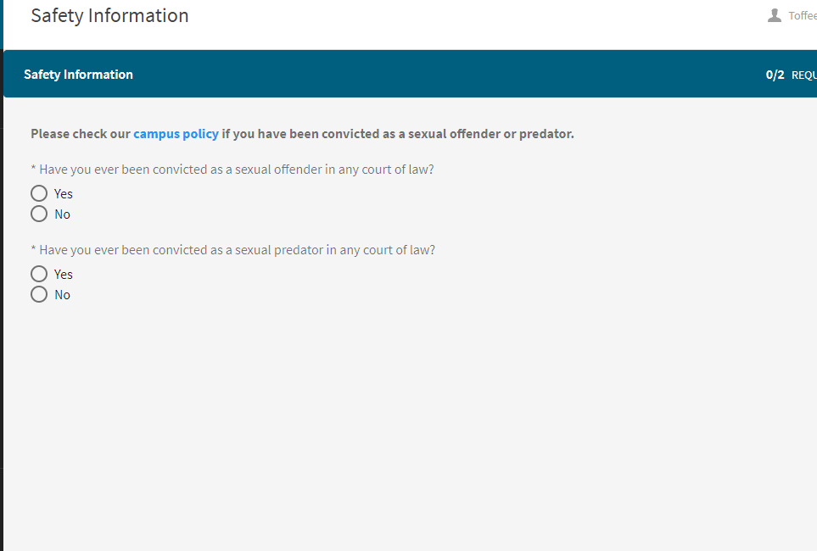

You will then be asked to confirm the term you intend to start as a traditional student and your degree and major.

After that, you will Submit your Application.

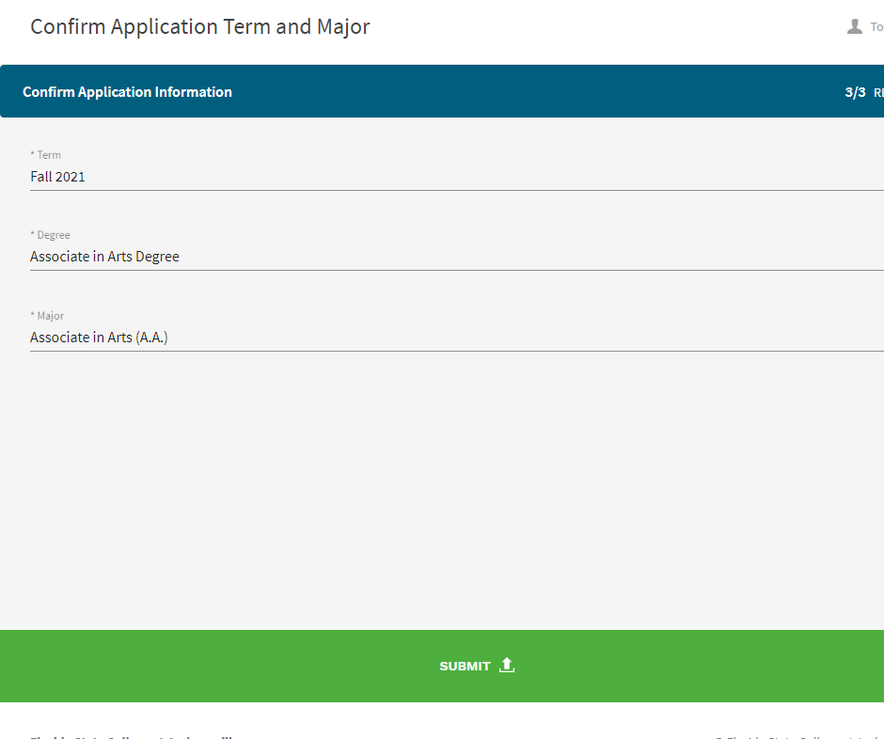

Click the Submit button to move ahead to the payment portal. Choose “Pay with Credit Card”, then click Make a Payment button.

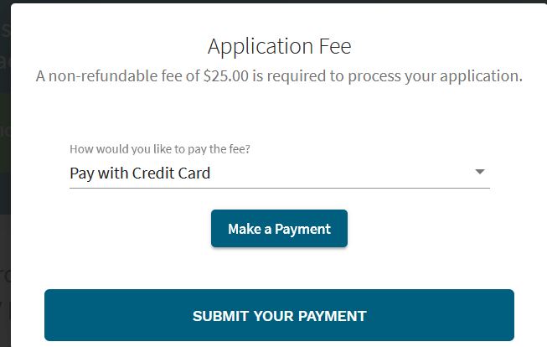

On the next screen you can choose to pay by eCheck or by Credit/Debit card.

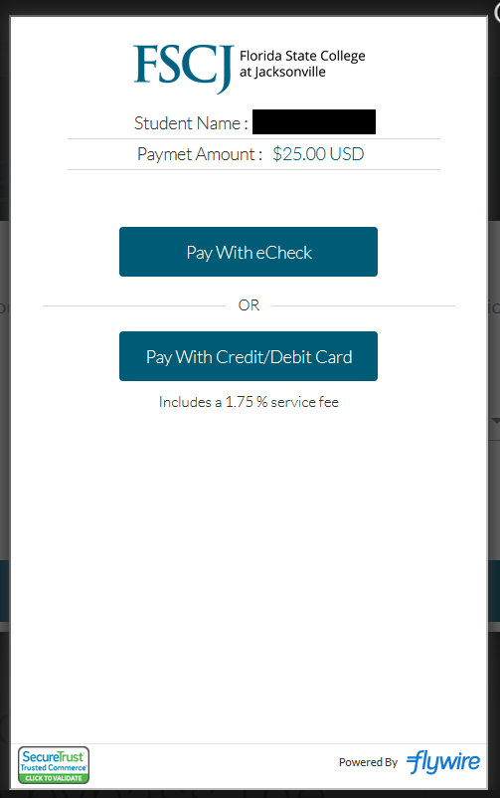

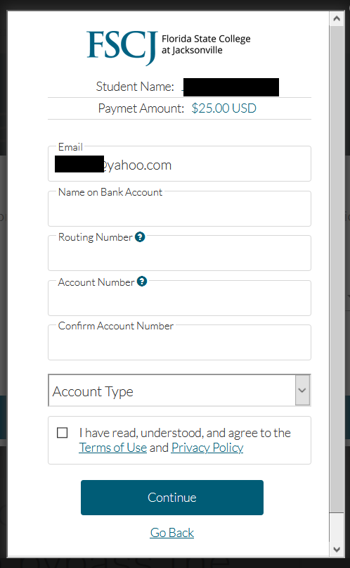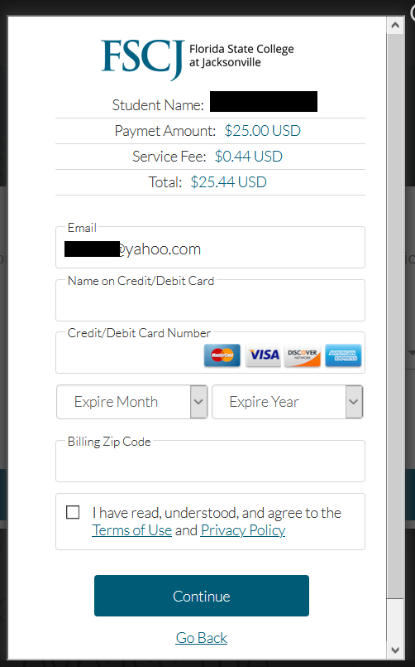

After you have submitted payment, you should receive confirmation and an email.

One more acknowledgement step, and then a final Submission.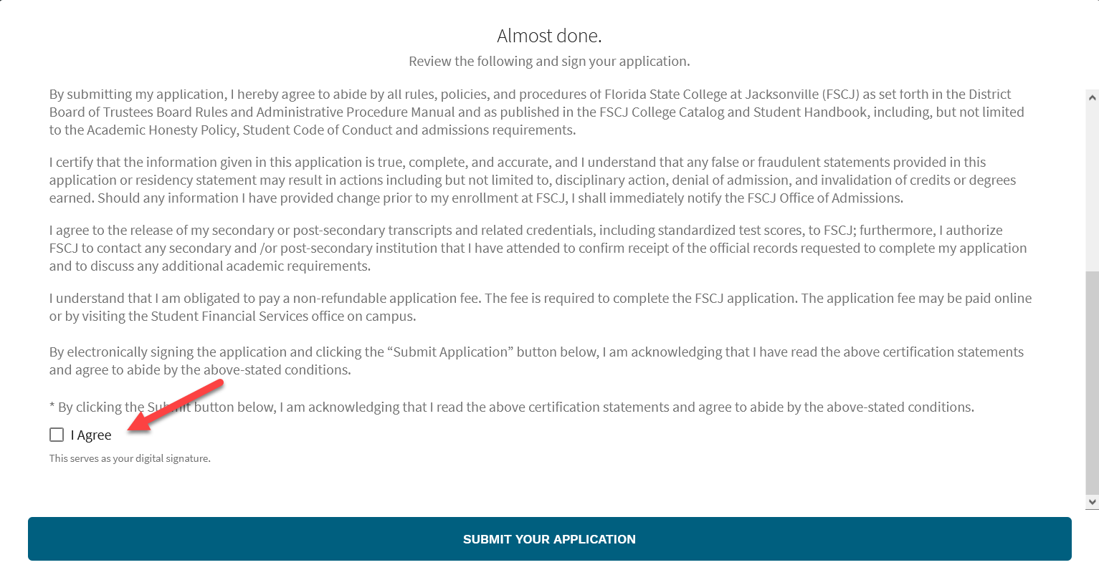

After you have submitted the full application, you should receive confirmation and an email. Remember that you will also need to complete Residency and provide documentation that you are a Florida Resident to receive the lowest tuition rate.